Virginia House of Burgesses
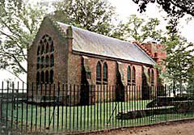
The first legislature anywhere in the English colonies in America was in Virginia. This was the House of Burgesses, and it first met on July 30, 1619, at a church in Jamestown. Its first order of business was to set a minimum price for the sale of tobacco.

The House of Burgesses soon became a symbol of representative government. The 22 members of the House of Burgesses were elected by the colony as a whole, or actually men over 17 who also owned land. Royally appointed councillors (of which there were usually six) and a governor rounded out the legislature. The governor was originally appointed by the Virginia Colony and later by the Crown.
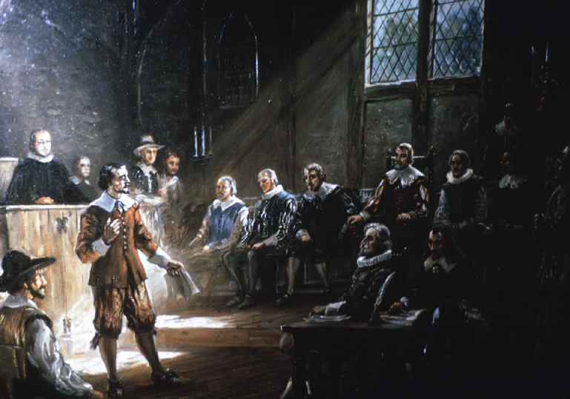
The House of Burgesses, which met at first only once a year, could make laws, which could be vetoed by the governor or the directors of the Virginia Company. This continued to be the standard until 1624, when Virginia became a royal colony. At this time, England took much more control of things in Virginia, restricting the powers of the House of Burgesses.

Through the years leading up to the Revolutionary War, many leaders of the move toward independence made their names in the House of Burgesses including Patrick Henry, George Washington and Thomas Jefferson.

The fact that the burgesses could make their own laws was very much on the mind of many people in the American colonies, especially when Great Britain continued to pass harsh laws that the colonists viewed as "taxation without representation."

Virginia House of Burgesses

- What first was the House of Burgesses? ________________________________________________

2. Based on the second paragraph what is a “representative government”? _______________________

_____________________________________________________________________________

3. What was the job of the House of Burgesses? ____________________________________________

4. What role did the House of Burgesses play in the American Revolution? ________________________
____________________________________________________________________________________

